* **Alpha and Beta Diversity Analysis Report**

Introduction

This report presents the results of alpha and beta diversity analyses performed on an OTU (Operational Taxonomic Units) table and metadata from a microbiome study. The aim was to compare the microbial diversity between anemia and non-anemia groups.

Data Description

- OTU Table: Contains the abundance of various OTUs across different samples.

- Metadata: Includes sample-specific information such as AGE, SEX, ANEMIA_STATUS, MCV, and NLR.

Methodology

1 Alpha Diversity Analysis

Alpha diversity measures the diversity within a single sample. We used the Shannon and Simpson indices for this analysis.

##### Statistical Tests

1. **Kruskal-Wallis Test**: To compare alpha diversity indices between anemia and non-anemia groups.

2. **Generalized Linear Model (GLM)**: To account for covariates such as AGE and SEX.

##### Results

###### Shannon Diversity Index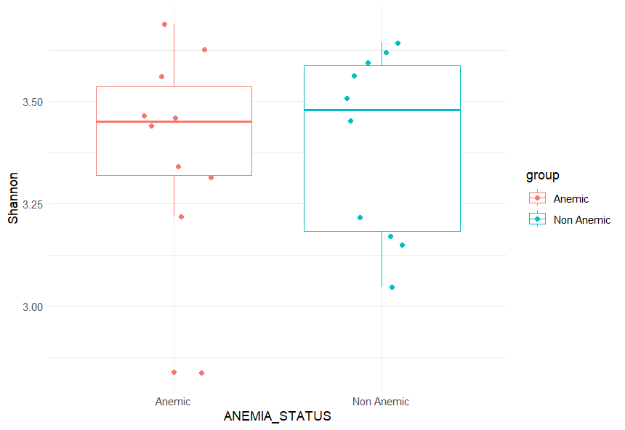

A tibble: 1 × 6

.y. n statistic df p method

* *<chr>* *<int>* *<dbl>* *<int>* *<dbl>* *<chr>*

1 Shannon 20 0.00571 1 0.94 Kruskal-Wallis

**Conclusion**: The p-value of 0.94 indicates no significant difference in Shannon diversity between the groups.

###### Simpson Diversity Index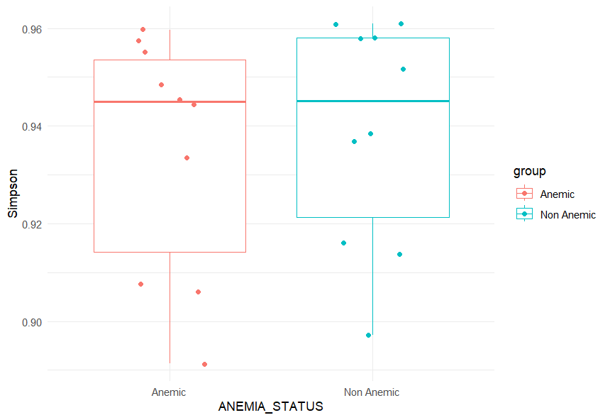

A tibble: 1 × 6

.y. n statistic df p method

* *<chr>* *<int>* *<dbl>* *<int>* *<dbl>* *<chr>*

1 Simpson 20 0.571 1 0.45 Kruskal-Wallis

**Conclusion**: The p-value of 0.45 from the Kruskal-Wallis test indicates no significant difference in Simpson diversity between the groups.

###### GLM Analysis for Shannon Index

Estimate Std. Error t value Pr(>|t|)

(Intercept) 1.1893710310 0.095485990 12.455974174 5.786771e-09

groupNon Anemic 0.0079221276 0.036230898 0.218656671 8.300729e-01

AGE 0.0011644841 0.001633287 0.712969496 4.875792e-01

SEXF -0.0005035983 0.054167431 -0.009297068 9.927133e-01

SEXM -0.0699839289 0.036865295 -1.898368908 7.845737e-02

SEXM 0.0072612388 0.048663048 0.149214633 8.835124e-01

**Conclusion**: The results show no significant effect of ANEMIA_STATUS, AGE, or SEX on Shannon diversity (all p-values > 0.05).

###### GLM Analysis for Simpson Index

Estimate Std. Error t value Pr(>|t|)

(Intercept) -0.0714432536 0.0365651855 -1.95386001 0.07099508

groupNon Anemic 0.0069689545 0.0138741768 0.50229679 0.62326649

AGE 0.0002257442 0.0006254473 0.36093246 0.72353811

SEXF 0.0087895734 0.0207427514 0.42374193 0.67819225

SEXM -0.0228432487 0.0141171111 -1.61812488 0.12793675

SEXM -0.0003894915 0.0186349156 -0.02090117 0.98361947

**Conclusion**: The results show no significant effect of ANEMIA_STATUS, AGE, or SEX on Simpson diversity (all p-values > 0.05).

### Beta Diversity Analysis

Beta diversity measures the differences in microbial community composition between samples.

#### Methods

1. **Bray-Curtis Distance**: To quantify the compositional dissimilarity between samples.

2. **Principal Coordinates Analysis (PCoA)**: To visualize beta diversity.

3. **PERMANOVA (adonis2)**: To statistically test the differences in microbial community composition between groups.

#### Results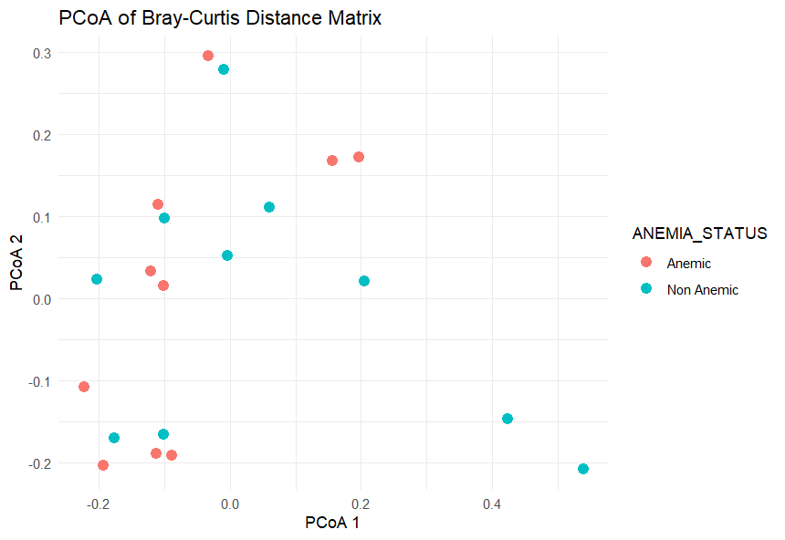

Permutation test for adonis under reduced model

Terms added sequentially (first to last)

Permutation: free

Number of permutations: 99

adonis2(formula = dist_matrix ~ ANEMIA_STATUS, data = as(sample_data(physeq), "data.frame"), permutations = 99)

Df SumOfSqs R2 F Pr(>F)

ANEMIA_STATUS 1 0.1509 0.04618 0.8714 0.54

Residual 18 3.1172 0.95382

Total 19 3.2681 1.00000

**Conclusion**: The PERMANOVA test resulted in a p-value of 0.54, indicating no significant difference in microbial community composition between anemia and non-anemia groups.

### Summary

The alpha diversity analysis using Shannon and Simpson indices showed no significant differences between anemia and non-anemia groups. The GLM analysis, accounting for covariates (AGE and SEX), also supported this finding. Beta diversity analysis using Bray-Curtis distances and PERMANOVA indicated no significant differences in microbial community composition between the groups.

### Final Remarks

The results suggest that anemia status does not significantly influence the microbial diversity or community composition in the studied samples. Further studies with larger sample sizes and additional covariates may be needed to confirm these findings.